YEAR 1 HOME LEARNING DURING SCHOOL CLOSURE
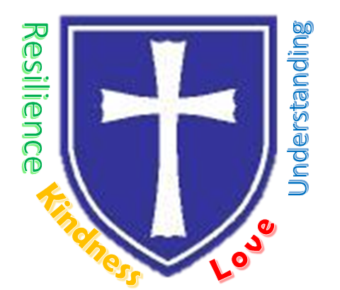
All Saints CE Primary School & Nursery
Nurturing, Resilience and Achievement for all!

Headteacher: Mr Philip Asher, BMus(Hons), PGCE, ARCO, NPQSL

Children learn best when they are relaxed and interested in the topic being taught. We appreciate that learning at home can be intense for the children and challenging for parents. Therefore, we suggest that for young children most of their learning takes place through play.

You may notice some changes to the format and quantity of the home learning this week. This is due to the fact that some children will be in school and some will be continuing to work from home. For home schooling please work at your own pace and ensure regular breaks are taken.

The whole school this week will be completing a topic activity based around an artist and one piece of art. We thought Year One would enjoy looking at this collage ‘The snail’ by Henri Matisse.

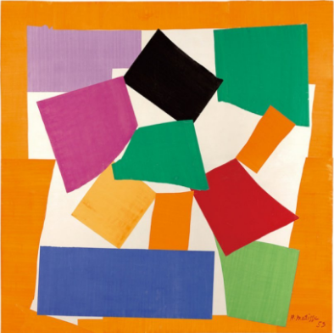

You could explore this at home by:
- Looking for snails (or other minibeasts) in the garden or at the park to look at shape / colours.
- Finding out more about your favourite minibeasts and making a little fact file.
- Making your own snail picture by:
  - Making a snail collage like Henri Matisse by cutting up and arranging magazine pages / leaflets / coloured paper.
  - Using Lego bricks to create a snail picture.
  - Printing using paint and the shape faces of 3d objects or blocks.
  - Create your own paint using water mixed with herbs / spices / leaves to create different colours.

As always, if you have any questions please use the following email parent@allsaints.herts.sch.uk

We hope you all had a super half term and hope you enjoy this week’s activities.
Have Fun!
Mrs Holland and Mrs Rutt

Parsonage Lane, Bishops Stortford, CM23 5BE
T: 01279 836006 E: admin@allsaints.herts.sch.uk

www.allsaints.herts.sch.uk @AllSaintsPriSch

Help your child to:  Learn to read using phonics | Help your child to:  Practise their reading |  | Help your child to:  Get to know the story of ‘Sayeeda, the Pirate Princess’ | Help your child to:  Get to know the story of ‘Sayeeda, the Pirate Princess’ |  | Help your child to:  Identify the beginning, middle and end of a story.
By:  Watch the DfE videos available from https://www.youtube.com/channel/UCP_FbjYUP_UtldV2K_-niWw/featured  Or search ‘letters and sounds for home and school’.  You will need a pen and paper.  Choose one session (daily if possible) and either watch live or recorded on the youtube channel.  Do one of:  10am Reception phonics revision  10.30 year 1 phonics  11am revising blending ready for year 1. | By:  Reading ebooks using Bug Club. To log on visit www.activelearnprimary.co.uk/login  Username:  First 4 letters of the first name and first 4 letters of last name.  Eg.for Matthew Smith the username is mattsmit  Password: allsaints  School code: qcx7 |  | By:  Read the story together (page 3 and 4) or listen at https://soundcloud.com/talkforwriting/sayeeda/s-ewAQuMNjrJt  This story is going to inspire our writing for the next few weeks.  Talk about the story and jot down your ideas on page 5.  Fancy a challenge? Complete the quiz on page 7. | By:  Page 6- Match up the words with the character who said them. |  | By:  Create your own comic strip of the story (sheet attached).  Who is the main character and what are they doing?  What warning do they get?  What happens next?  Who helps Sayeeda?  How does the story end?
Help your child to:  To compare volume in a container by describing whether it is full, nearly full, empty or nearly empty. |  | Help your child to:  To measure the capacity of different containers using non-standard units of measure. |  |  | Help your child to:  To use non- standard units of measure to compare capacity.
By:  Provide a range of different containers for children to explore practically using water / sand rice. Challenge them to show you a container that is full / empty / almost full / almost empty.  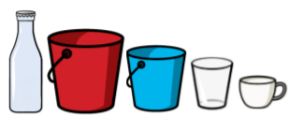  Watch this video to support:  https://whiterosemaths.com/homelearning/year-1/  Then select Summer Term Week 6 (w/c 1ts June)  Lesson 3.  Explore capacity outside using a range of different containers to fill and describe using the above vocabulary.  Complete L1 introduction to capacity. |  | By:  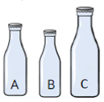  Explore practically using a variety of containers. Investigate how many small containers it takes to fill the larger container.  Take 3 different containers. Fill each with water / rice using the same unit of measuring – e.g. cup. How many cups of water for each container? Which container holds the most? Which one holds the least? Now order the containers from largest to smallest capacity. Use more than/ less than / equal to as well as the symbols <, > and = to compare. You could create your own poster to record. Please share on Google classroom.  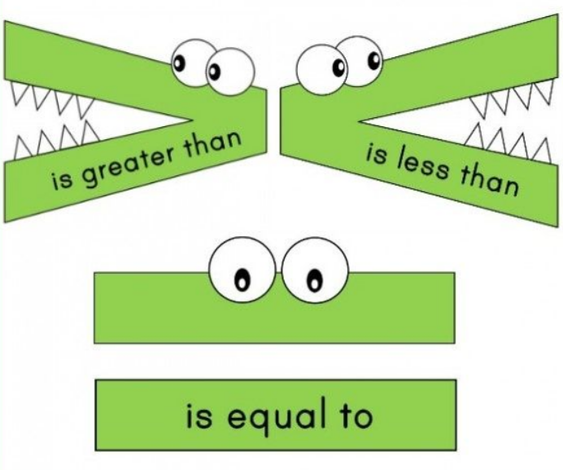  You could complete the L2 measure and compare capacity sheet. |  |  | By:  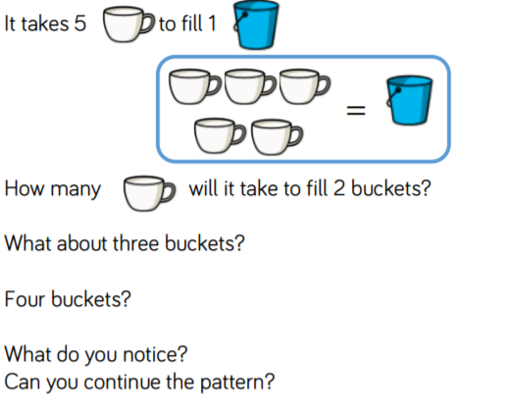  Watch this video to support:  https://whiterosemaths.com/homelearning/year-1/  Then select Summer Term Week 6 (w/c 1ts June)  Lesson 4.  Again investigate outside practically to measure using different containers –  Complete L2 measuring capacity.

Useful links
English
https://literacytrust.org.uk/family-zone/
http://www.pobble365.com/
https://www.storynory.com/

Phonics
https://www.twinkl.co.uk/resources/literacy/literacy-phonics
https://www.phonicsplay.co.uk/
https://www.phonicsbloom.com
Phonics: alphablocks available on BBCiplayer and YouTube

High frequency word games
https://www.teachyourmonstertoread.com/ (free on computer, app requires payment)
Reading and sentence games https://www.roythezebra.com/reading-games.html (need to watch or close short adverts to play free games)
Free ebooks https://www.oxfordowl.co.uk/for-home/reading

Spelling games
https://www.spellzone.com/
https://spellingframe.co.uk/ (Year 2 children have a log in)

Maths
https://www.topmarks.co.uk

Other
http://myths.e2bn.org/mythsandlegends/
https://www.dkfindout.com/uk/
https://www.kiddle.co/

